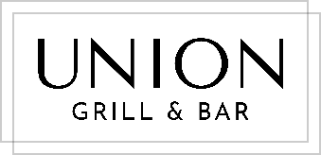

STEAK NIGHT

“BISTRO” TENDERLOIN $29
6oz Certified Angus

***

20% OFF ALL PREMIUM STEAKS

FILET MIGNON $49
8oz Certified Angus

NEW YORK STRIP $48
14oz Certified Angus

RIB EYE $47
12oz Rib Eye, bone-out

T-BONE $65
16oz Certified Angus

COW-GIRL $70
16oz Certified Angus, bone-in

TOMAHAWK $125
34oz Certified Angus, Asparagus, Two Sauces

DRY-AGED RIB EYE $75
16oz Certified Angus, bone-in

All steaks come with a choice of house fries or buttered mash, plus one sauce, and a glass of house red, wihite, Caybrew beer or Prosecco.

(except Tomahawk which includes asparagus and two sauces).

Trade up to truffle parmesan fries $2 extra.

A 15% gratuity will be added to final checks.

