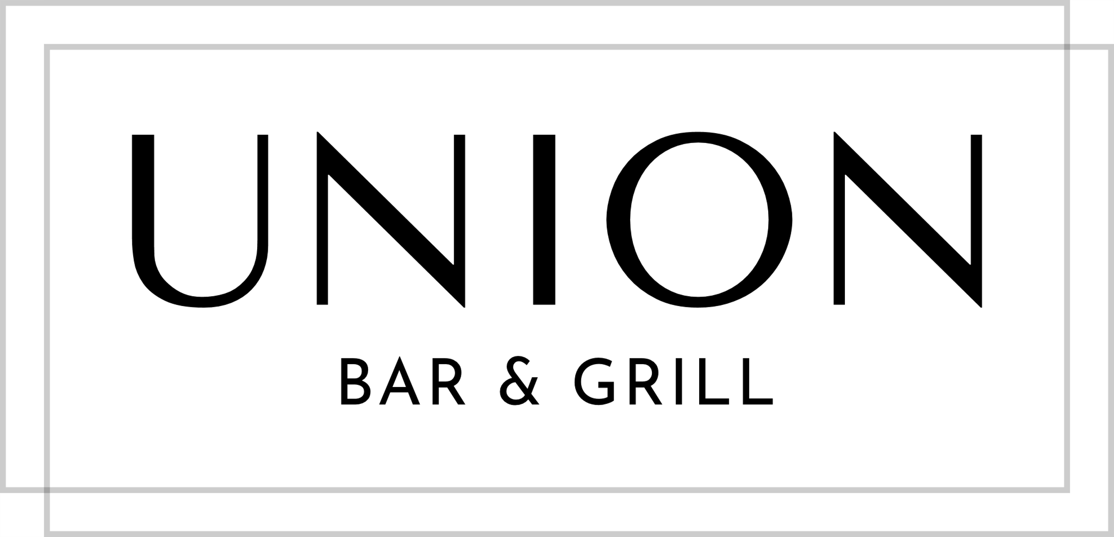

BURGER FEST

All burgers are served with a brioche bun and togarashi fries
Upgrade to truffle & parmesan fries $2 extra

CAB BEEF BURGER (gfo)
triple blend 8oz CAB patty, onion jam, house pickles, chipotle mayo, iceberg, tomato
$20
make it a cheeseburger: Cheddar, Pepper Jack, Blue $4
add crispy bacon $2

LAMB BURGER (gfo)
8oz New Zealand lamb patty, feta tzatziki, onion jam, shaved cucumber, arugula
$22

KOREAN PULLED PORK
pulled Korean BBQ pork, house-made kimchi, Asian slaw, lettuce
$20

CRISPY PANKO CHICKEN
panko-crusted chicken breast, escovitch pickles, honey mustard sauce, lettuce
$20
add crispy bacon $2

CHARGRILLED LOBSTER (gfo)
chargrilled lobster tail, melted Brie, crispy bacon, lemon hollandaise, cucumber, lettuce
$28

BLACKENED FISH (gfo)
catch of the day, escovitch pickles, house-made tartare sauce, cucumber ribbons, iceberg
$20

VEGAN (ve, gfo)
falafel, guacamole, charred veggies, lemon hummus, vegan bun
$20

(v) = vegetarian, (ve) = vegan, (veo) = vegan option, (gf) = gluten free, (gfo) = gluten free option
(cn) = contains nuts. Please advise your server of any dietary restrictions.
All prices in CI$: 1 CI$ = 1.25 US$. A 15% gratuity will be added to final checks.

